MATTHEW McCASLIN

Crossroads
April 23 – June 6, 2009

Counter clockwise from right

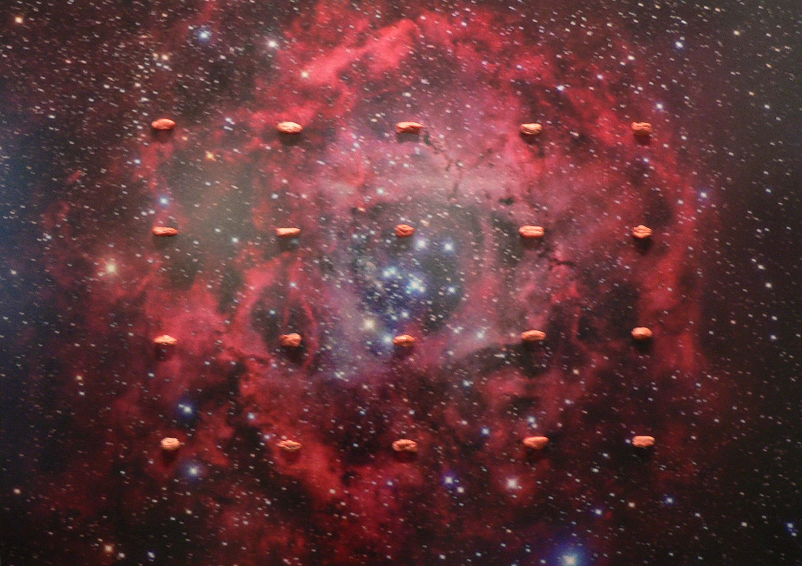
Bite the Bullet, 2009
Photograph mounted on aluminum, chewing gum
29 1/2 x 41 1/2 x 1 1/2 inches
Unique

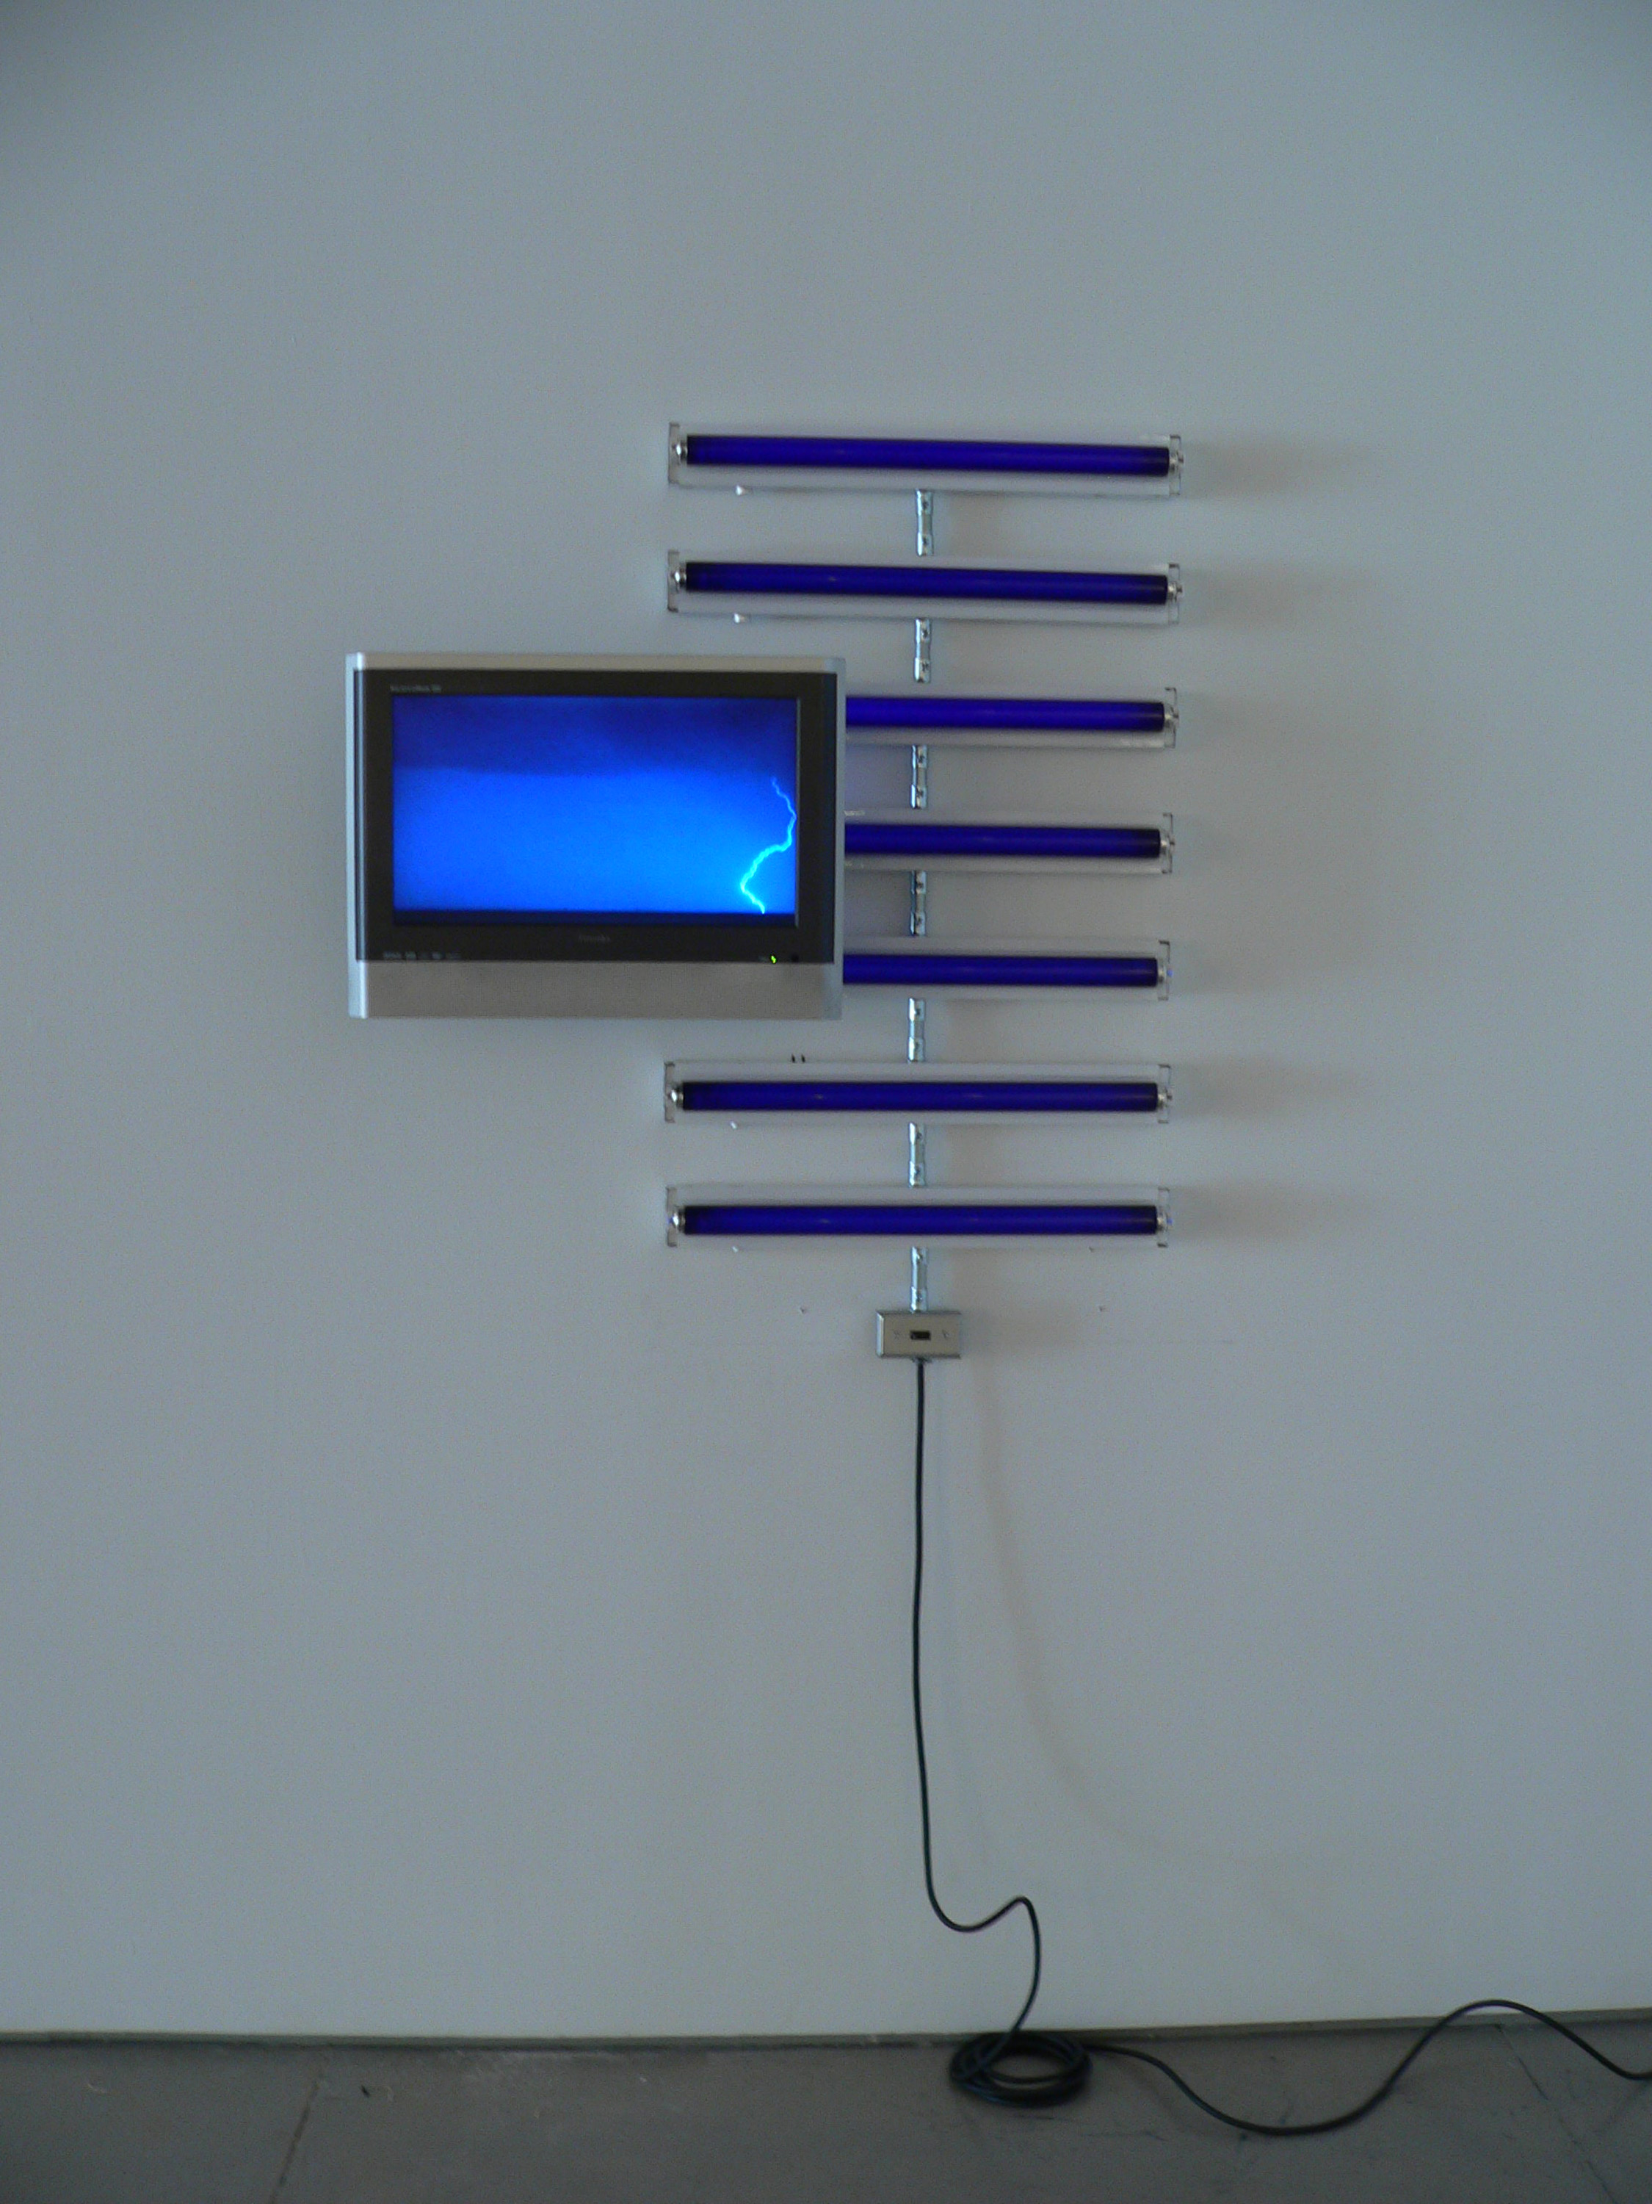
Electric Life Drawing, 2009
Fluorescent light fixtures, black light bulbs, flat screen TV/DVD player,
DVD, electrical hardware
39 x 44 x 9 1/2 inches
Unique

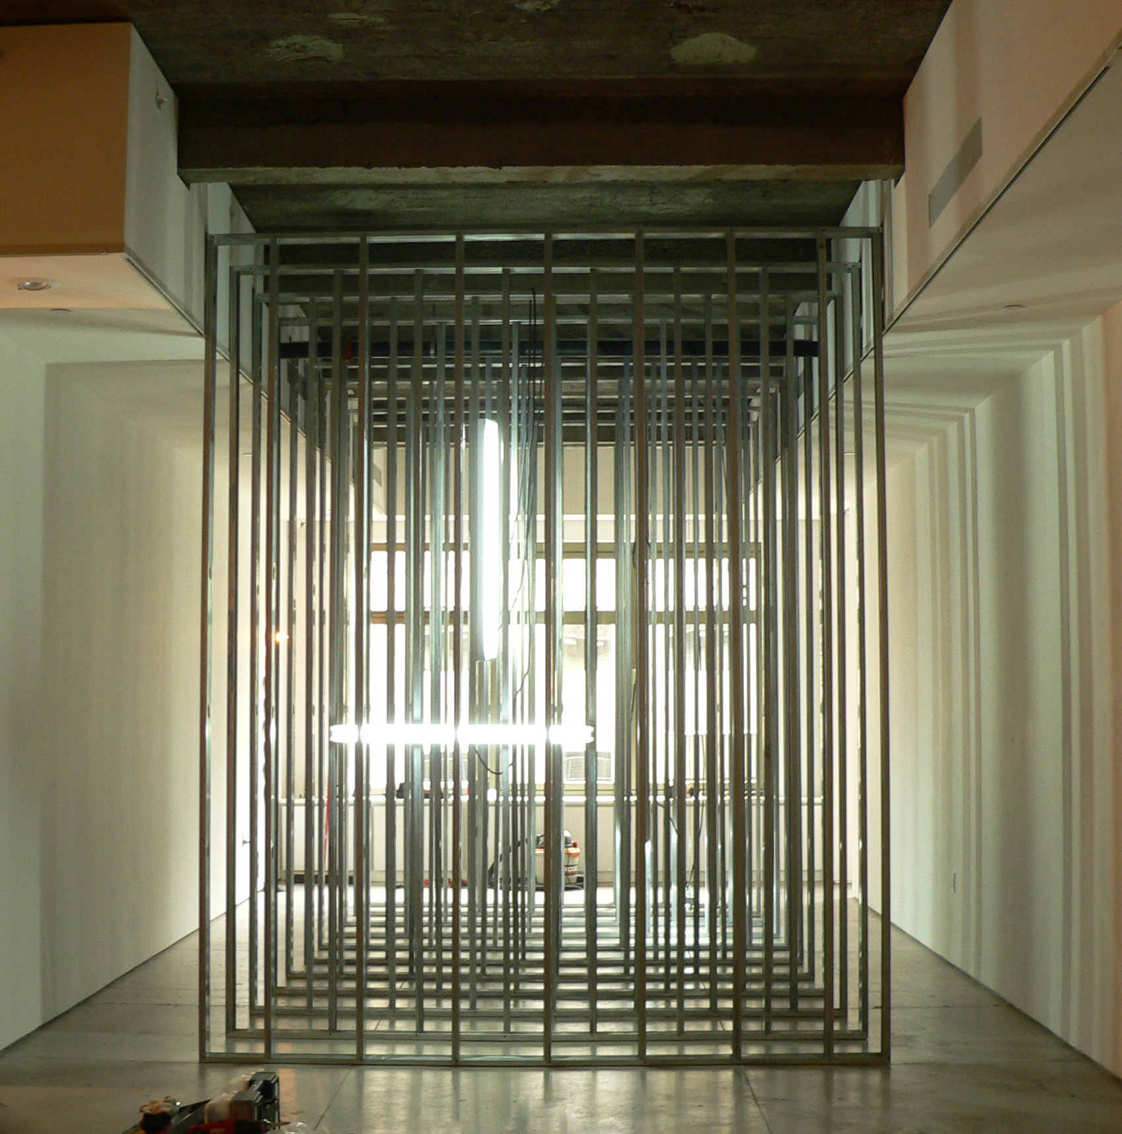
Inside Out, 2009
Aluminum studs, fluorescent light fixtures, fluorescent light bulbs,
electrical hardware
144 x 120 x 245 inches
Unique

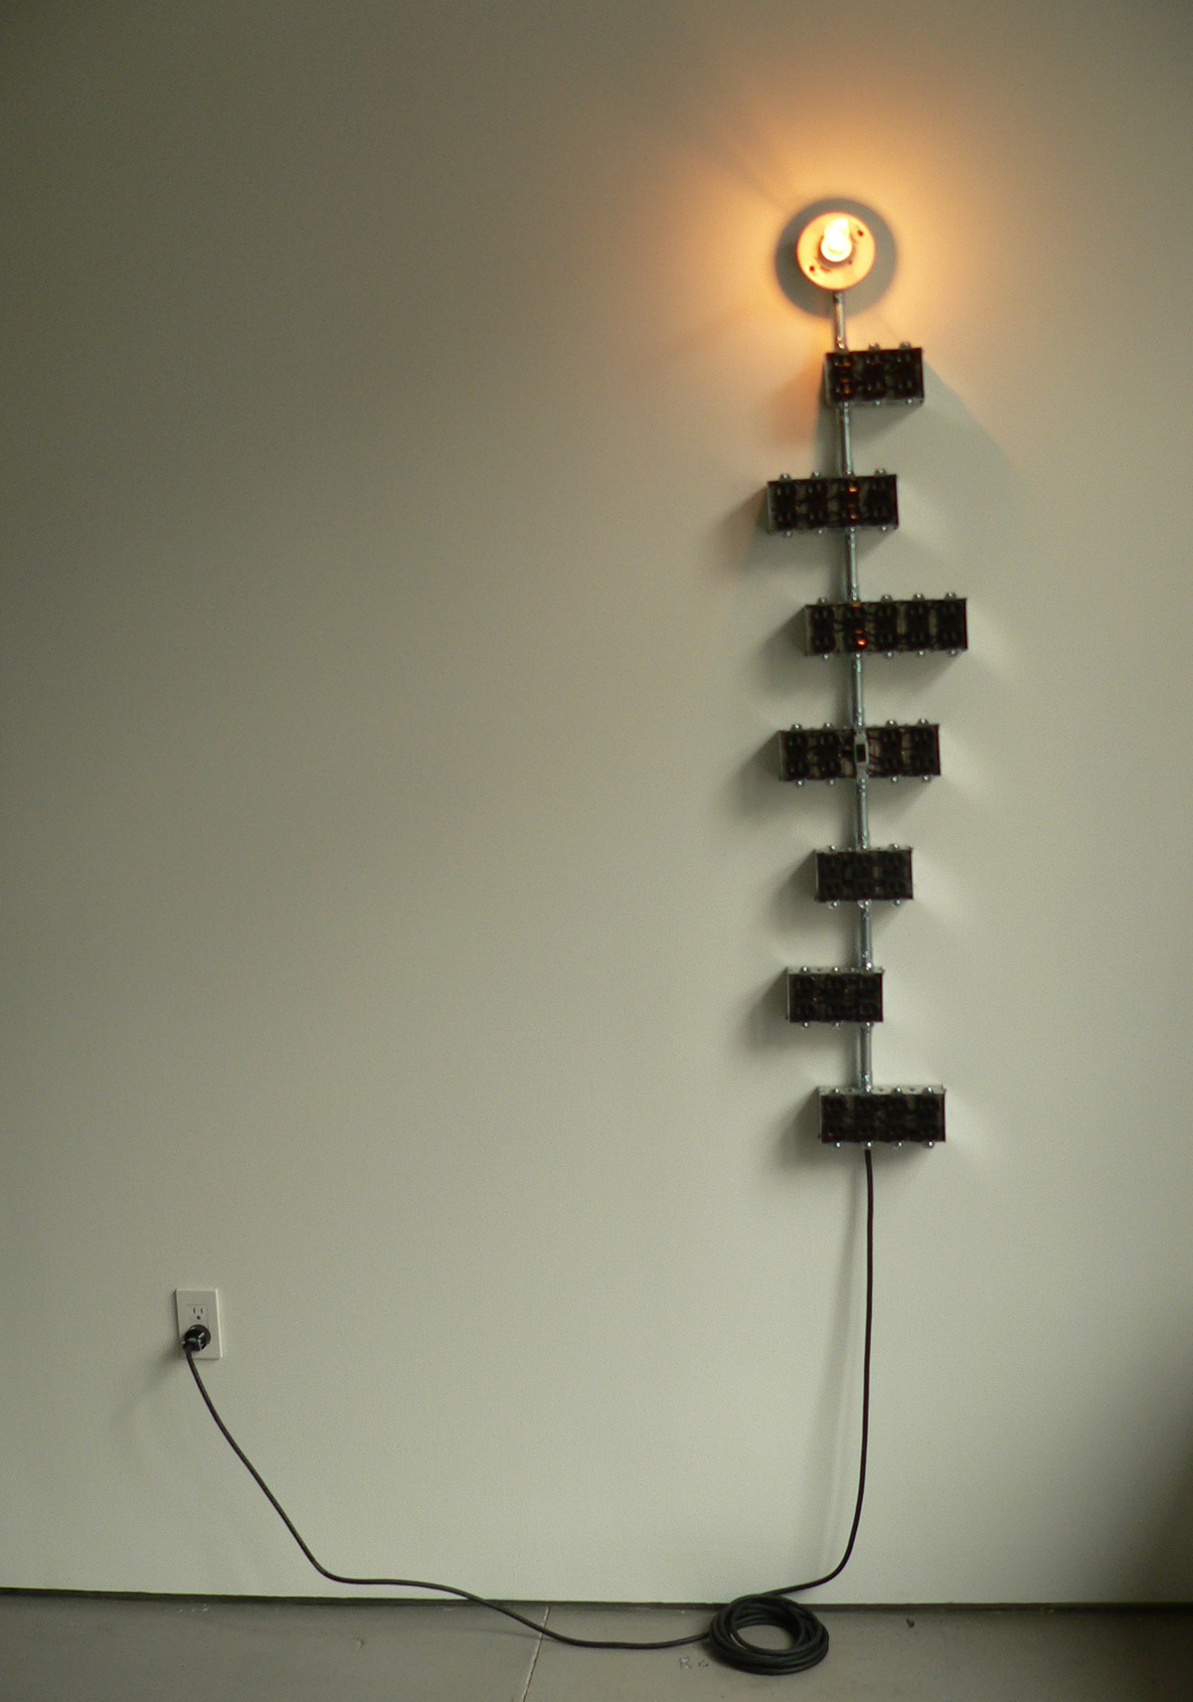
David Smith, 2009
Electrical hardware, porcelain light socket, light bulb
54 x 11 x 7 inches
Unique

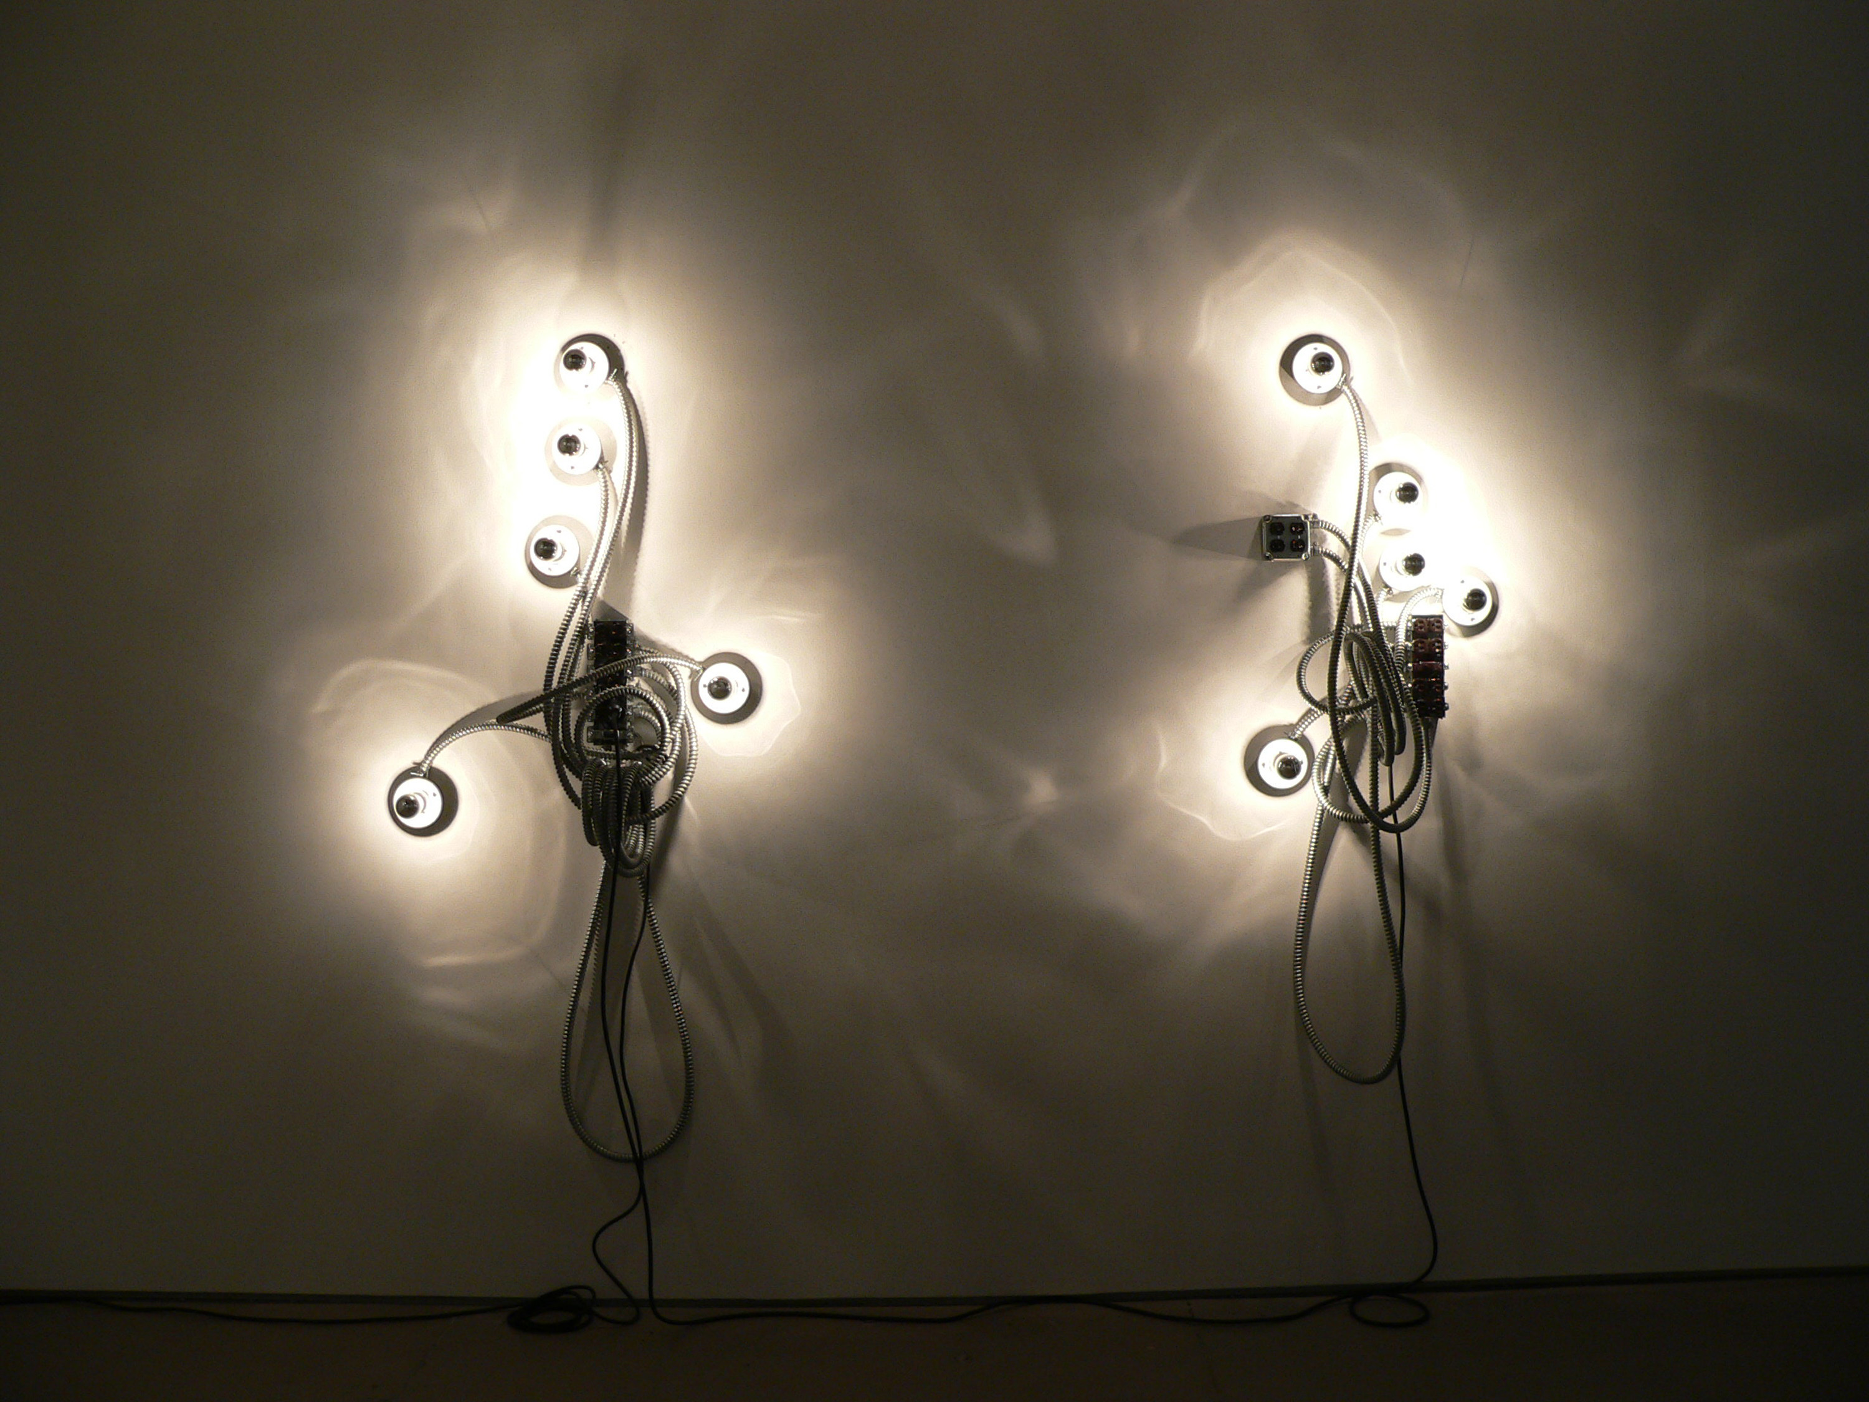
He or She and She or He, 2009
Flexible electrical conduit, porcelain light sockets,
mirrored light bulbs, electrical hardware
Unique

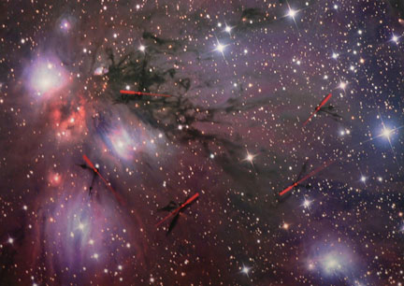
I’m Late, 2009
Photograph mounted on aluminum, battery operated clock mechanisms
29 1/2 x 41 1/2 x 1 1/2 inches
Unique

